Electronics and Communication Engineering
VISION
To excel in the emerging area of Electronics and Communication Engineering by imparting
knowledge with relevant practices to meet the industrial and societal needs.
MISSION
- M1: Imparting quality technical education to the students by providing excellent teaching.
- M2: Establishing Industry institute interaction to make students ready for the industrial environment.
- M3: Inculcating ethical values and leadership abilities in the students so as to work towards the growth of the society.
Program Educational Objectives Statements
- Demonstrate, update and adapt domain knowledge in the area of Electronics and Communication Engineering and the allied fields to propose solutions for the core industry in the ever changing global enterprise with ethical practices.
- Assume leadership roles and succeed in their chosen career path, in industry or public service through engineering ability, life skills and multidisciplinary skill set acquired.
- Pursue higher education institutes of national level.
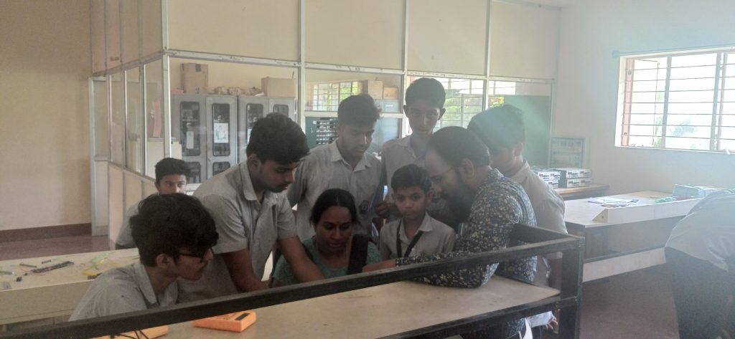
FROM HOD’S DESK
- The Electronics & Communication Engineering Department was established in year 1987, recognized by DTE, Bengaluru and affiliated to AICTE, New Delhi. The current intake is 60 students.
- The department has modern, well-equipped Laboratories with adequate facilities, with high end electronic gadgets.
- It is committed to provide students with an environment for overall development.
- The department has consistent academic record and also provides excellent career opportunities in various sectors, through placement.
- Many students are serving at reputed organizations like ABB, Werth Electronics, AT&S, L&T Infotech and those who are pursuing higher studies are studying in prestigious Engineering colleges, like PESIT, SJCE, NIE.
- Staff and students are provided with unlimited free internet access at e-Library during spare time, so that they can develop and enhance their knowledge acquired in class rooms.
SL No. | Image | NAME | DESIGNATION | QUALIFICATION | Date of Joining | Profile
1 | 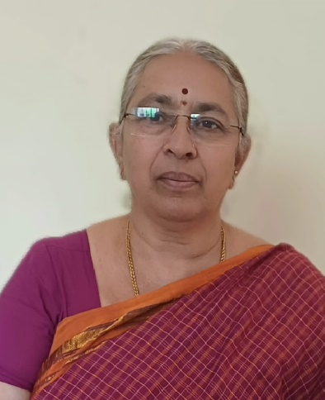 | Dr. Asha Kulkarni | HOD | PhD | 15/9/1997 | click here to view
2 |  | Yamuna K | Lecturer | MTech | 09-03-1998 | click here to view
3 |  | Vimala H N | Lecturer | BE | 25/7/2003 | click here to view
4 |  | Pavithra B | Lecturer | MTech | 07-10-2006 | click here to view
5 | 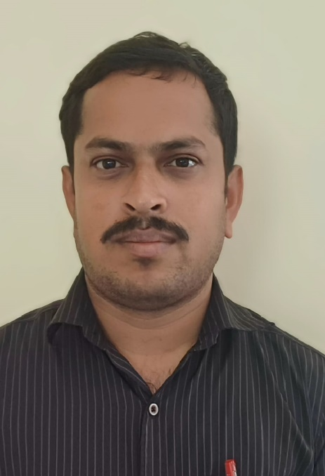 | Niranjanamurthy M | Lecturer | BE | 19/10/2013 | click here to view
6 |  | Parashivamurthy | Lecturer | BE | 25/3/1998 | click here to view
7 | 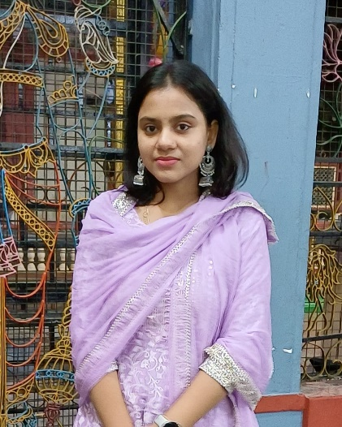 | Yogitha M S | Lecturer | BE | 01-07-2024 | click here to view

Note:All Employees is nature of association is regular
LIST OF SUPPORTING STAFF
SL No. | Image | NAME | DESIGNATION | QUALIFICATION
1 |  | Rashmi N S | Instructor | DEC
2 |  | Chandrashekara M P | Instructor | DEC
3 |  | Manjunath S R | Instructor | DEC
4 | 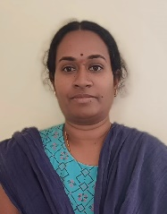 | Shilpa G | Mechanic | ITI, BA
5 |  | Srikantamurthy | Lab Helper | ITI

